H.W 8-3
- Let’s write down the regression line equation when using Carat as the independent variable and Price as the dependent variable.
Let y = β₀ + β₁ x be the regression line equation.
Assumptions:
- Both variables come from a random sample
- Scatter plot
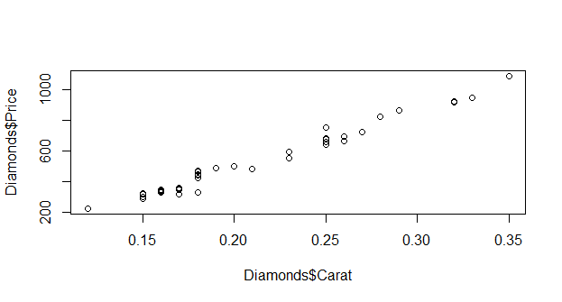
We can observe a linear relationship between price and carat.

- Normality test of both variables
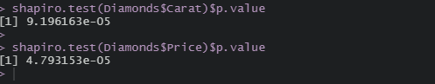
Since the both p-value less than 0.05 (9.19e-5 for carat size and 4.79e-5 for price), implies that data distribution are different from the normal distribution. Hence we cannot assume normality of both variables.
We assume that these hypotheses are verified in order to determine the equation of the regression line
Code: 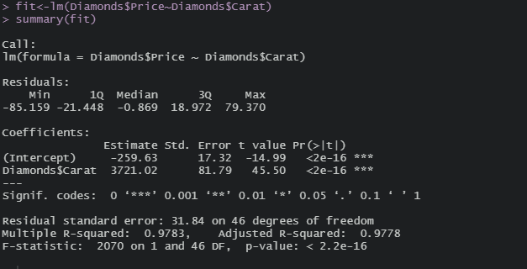
Conclude and interpretation:
Hence, we can write the regression line equation like this:
$$\hat{y}=-259.63+3721.02x$$

- Let’s interpret R² value
The R² is 0.9783 or 97.83%. That means that 97.86% of the variation in diamond price is accounted for by our regression equation.

- Test the hypothesis that β ≠ 0
Let y = β₀ + β₁ X be the regression line equation. Β₀ represents the intercept and β₁ is the slope.
Hypotheses:
H₀: β₁ = 0
H_{a}: β₁ $≠$ 0
Conclude and interpretation:
With an alpha of 0.05 and p-value<2.2-16, we reject the null and state that we have sufficient evidence to support that the true slope between price and carat size is not equal to zero.
- Let’s predict price of a diamond with a carat size of 0.3
y = -259.63 + 3721.02* 0.3
The predicted price of a diamond with a carat size of 0.3 is 856.676
- Let’s predict price of a diamond with a carat size of 0.7
y = -259.63 + 3721.02* 0.7
The predicted price of a diamond with a carat size of 0.3 is 2345.084
No, we can't trust this estimate because the value of estimating (0.7) is outside the range of carat variable.
- Let’s determine the correlation of two variables.
Assumptions:
These assumptions were tested in the first question.
Code:
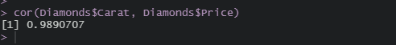
Conclude
The correlation between diamond price and carat size is 0.989

- Let’s test that ρ ≠ 0
Let ρ be the true correlation between diamond price and carat size.
Hypotheses:
H₀: ρ = 0
H_{a}: ρ ≠ 0
Code:
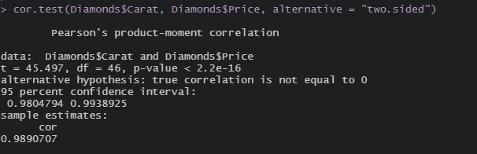
Conclude and interpretation:
With an alpha of 0.05 and p-value < 2.2e-16, we reject the null and state that we have sufficient evidence to support that the true correlation between diamond price and carat size is not equal to zero.

- No, I couldn't say that a higher carat causes higher diamond prices based on only correlation, because when two variables have a strong correlation does not mean that one causes the other.

